British preparatory attack on the Mareth Line

16th March 1943: A vivid account from an Artillery officer going forward with the infantry for a night attack
MAR 16

SAVE |  | ▷ LISTEN

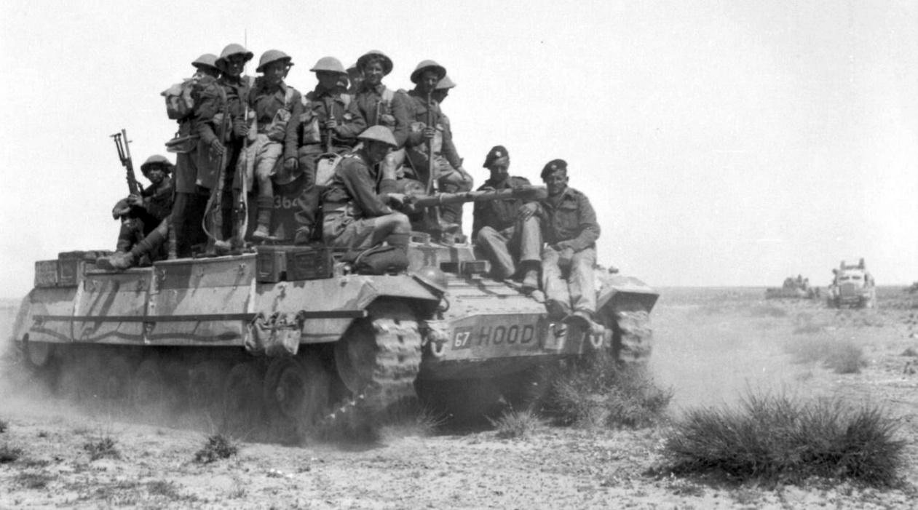
The British were preparing for a major attack in Tunisia. A Valentine tank carries infantry during an exercise, 12 March 1943
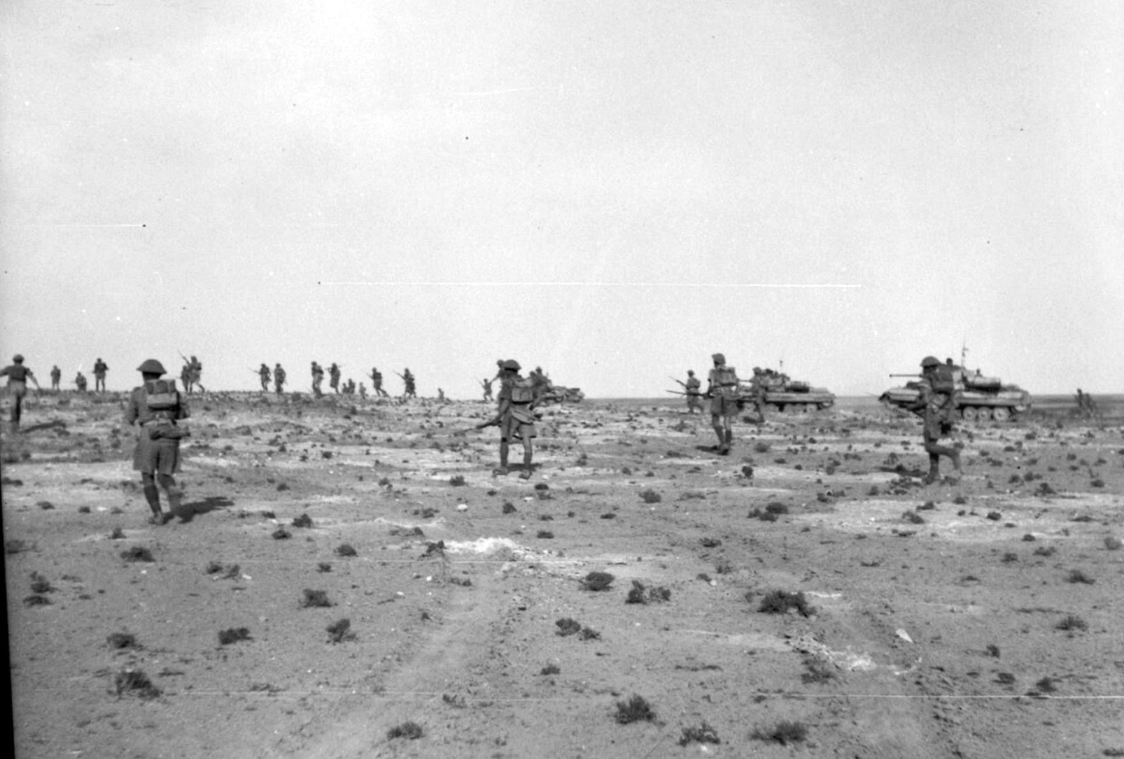
Infantry and Valentine tanks advance during an exercise, 12 March 1943.
In Tunisia the Mareth line was hotting up as the 8th Army made preparations for their biggest attack since el Alamein. A series of raids and probing attacks were being mounted, mainly at night.
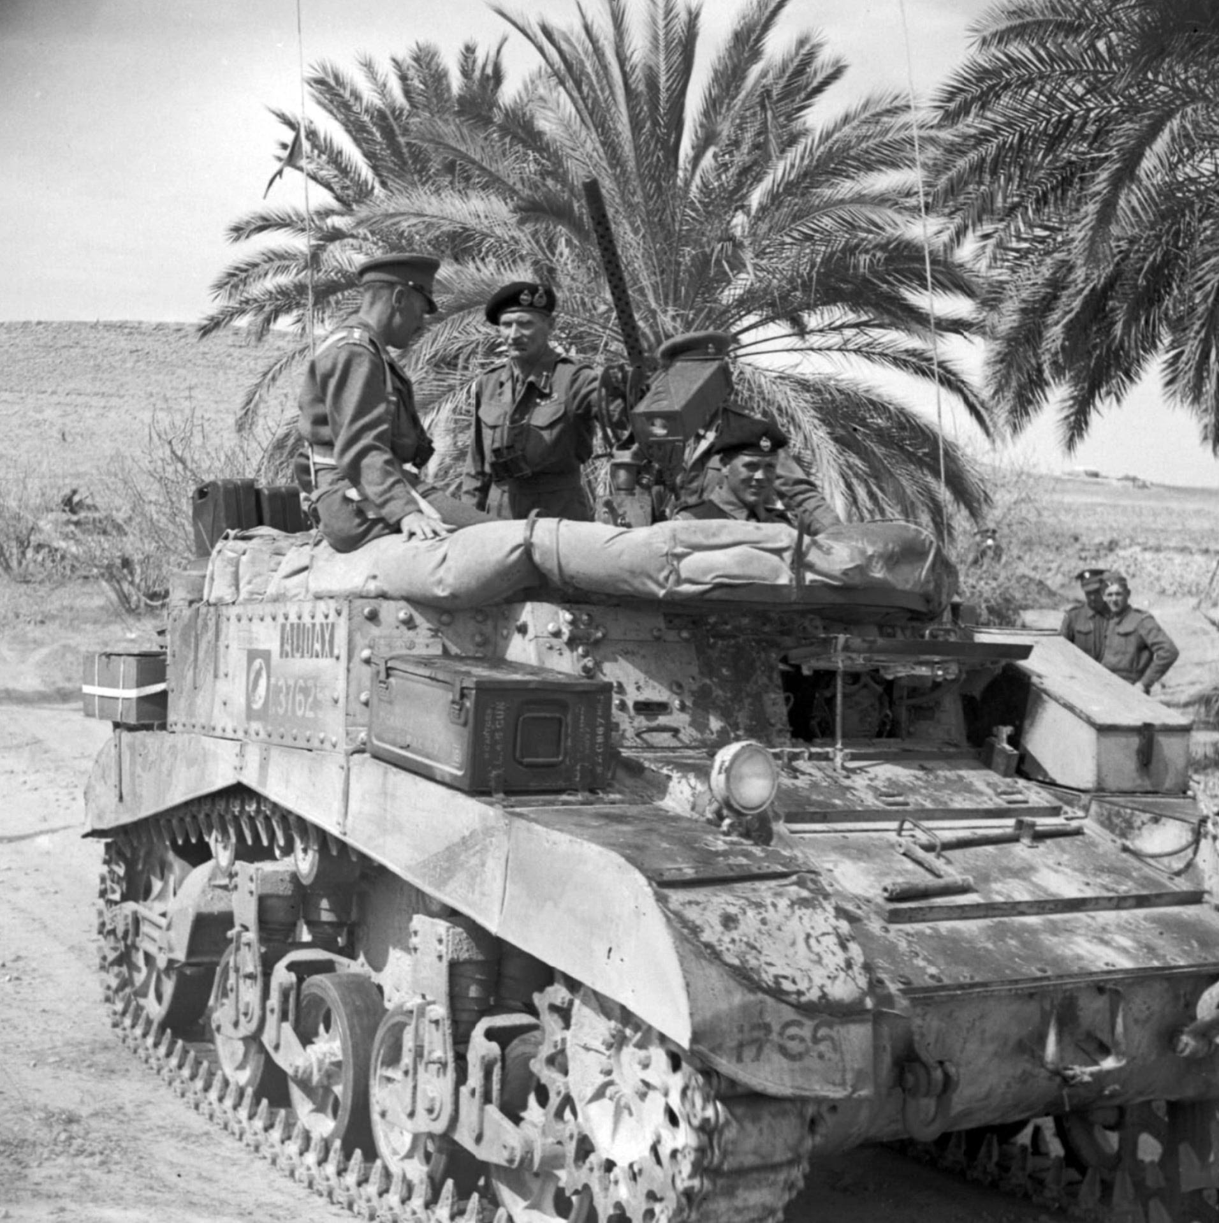
General Montgomery with Lt-Col A C Clive of the Grenadier Guards in a turretless Stuart command tank, 8 March 1943.
For the gunners in the Artillery such attacks meant long hours of hard physical labour feeding the guns. Then the main hazard was counter-battery fire from the German guns or possibly a bombing attack. For the infantry going forward there were all these dangers plus plenty more.
Then the fun really started. They were shelling that valley quite hard. Once we were lying flat and if you imagine we were the centre dot of a domino 5, we had 4 all round us about 20-25 yards away. They don't whistle when they get close but make a kind of screaming hiss which is very frightening.

Going forward with the infantry on the 16th March was Artillery officer Jack Swaab¹ who went up to the Artillery Forward Observation Point. At the FOP a junior officer maintained observation of the fall of shot and communicated target information back to the guns, usually by means of a field telephone.
On this occasion Swaab, who had only arrived in the field at the beginning of the year, was doing it for 'experience':
We left here at 6.30 pm and by about 9 had reached the infantry debussing point. There was a bright half moon and the night was noisy with our guns whose flashes could be seen round the horizon. Later the Boche air force joined in, bombing back areas by the light of bright yellow flares.
All this was the artillery preparation for the Guards and 50 Div. who put in the first attacks. By 2300 we were up at the F.O.P. where the Germans started shelling us fairly violently. Luckily we were in the middle and most of them fell just right and left of us.
At about 0100 our Vickers opened up with a most devilish pandemonium, firing cross the valley we had to cross. Overhead our shells were singing towards the ridge we could just see - our objective - and enemy shells and mortar bombs fell among us.
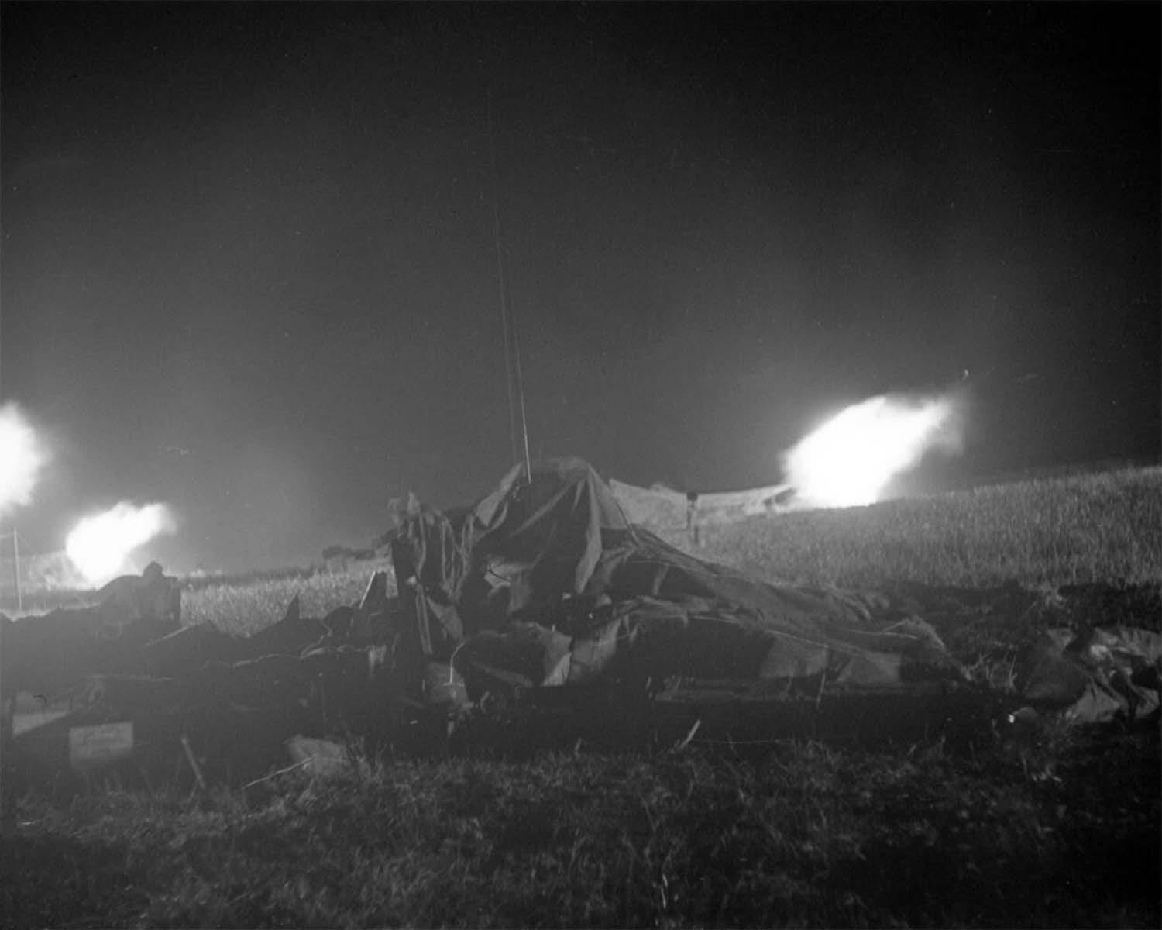
The Royal Artillery supporting an Infantry attack at night, Tunisia, 1943.
… bravery in battle is a curious business. It certainly is not accounted brave to be foolhardy and when shells are flying, you see people lying flat and making no bones about it. I believe that we suffered casualties around this point - I suppose it was about 0330 by then and we were feeling tired, cold, and footsore …
Once I heard a man screaming and sobbing as they scored a hit. I put on my tin hat and lay flat. Eventually the infantry (and my god, what guts these boys have got) went over the ridge and were driven back by m.g. fire but went on again, and we went after them with our cable reeling it out on foot.
Then the fun really started. They were shelling that valley quite hard. Once we were lying flat and if you imagine we were the centre dot of a domino 5, we had 4 all round us about 20-25 yards away. They don't whistle when they get close but make a kind of screaming hiss which is very frightening.
I found a Gordon with his leg badly smashed by shell splinters. He was lying there in the smoke and cold so I gave him my coat. Later I managed to get a couple of stretcher bearers to him and thus got my coat back. The bearers were as gentle as women with him and I realised the goodness as well as the evil in men afresh.
Soon after this our artillery put down an ill-conceived smoke screen, which in the still night failed to rise at all, and soon we were groping and stumbling along in a dense fog which made us cough and stung our throats.
I don’t know what time it was when we crossed the Wadi Zeuss and got into the gap in the enemy minefield. Time lost its ordinary values, even tho' I did check it frequently on the luminous face of my watch. The minefield gap lay just the other side of a marsh and was a thin lane marked by white tapes and lighted by tiny lights which seemed to shine like beacons.
Two Scorpions - the converted Matildas we use for clearing gaps - lay like huge unwieldy beetles, stuck in the bad going. Three machine gun posts stammered in front of us in the fog of smoke and the bullets buzzed and whee-ed over our heads.
On the right - a mine went up and I heard for the first time that curious wailing cry ‘Stretcher Bearers’ and again the groaning of the wounded. Sappers were everywhere, taping and picketing the gap: they are brave and efficient.
But bravery in battle is a curious business. It certainly is not accounted brave to be foolhardy and when shells are flying, you see people lying flat and making no bones about it. I believe that we suffered casualties around this point - I suppose it was about 0330 by then and we were feeling tired, cold, and footsore and craved a cigarette which we couldn't have.
To cut a long story short we were on our objective soon after 0400. In the gloom figures poked about with tommy guns and bayonets.
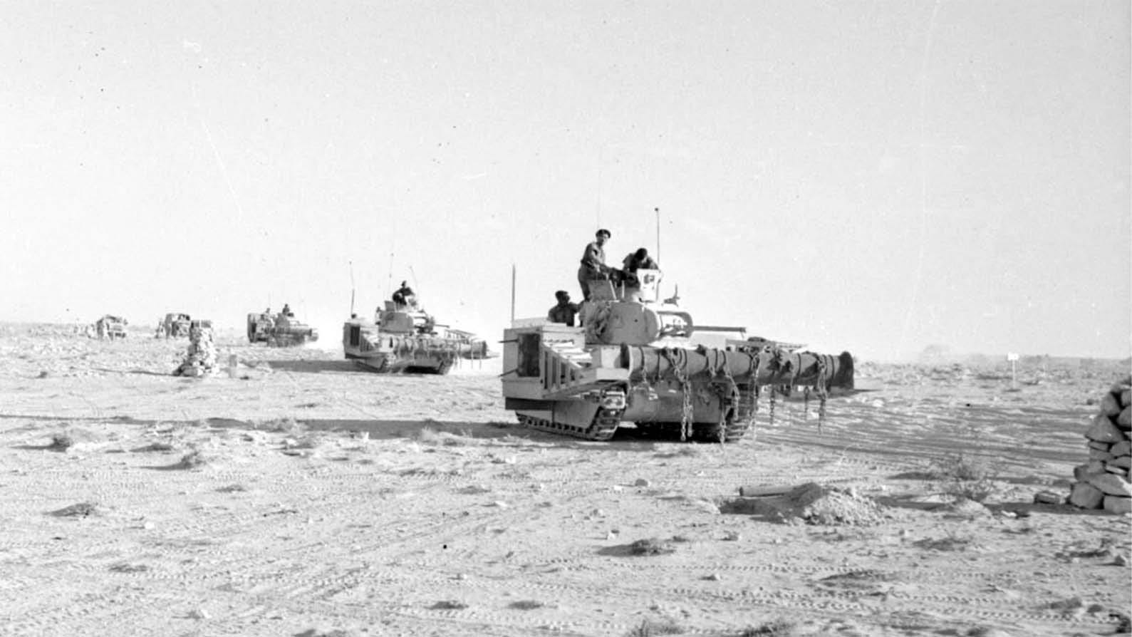
Matilda Scorpion flail tanks, used to clear a path through minefields, seen earlier in the campaign.
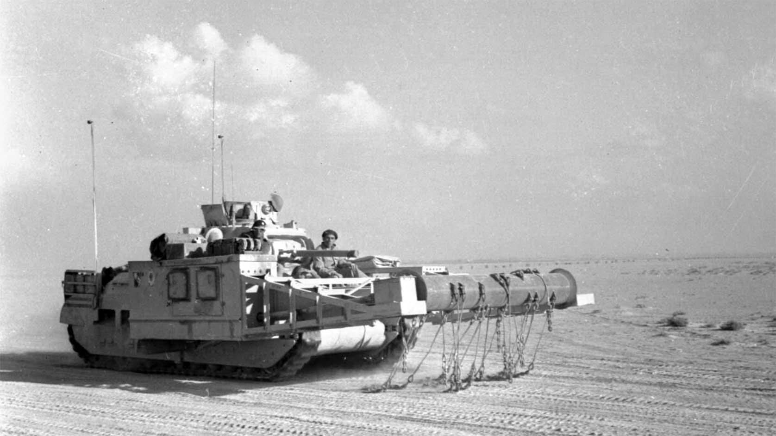
Matilda Scorpion flail tank.
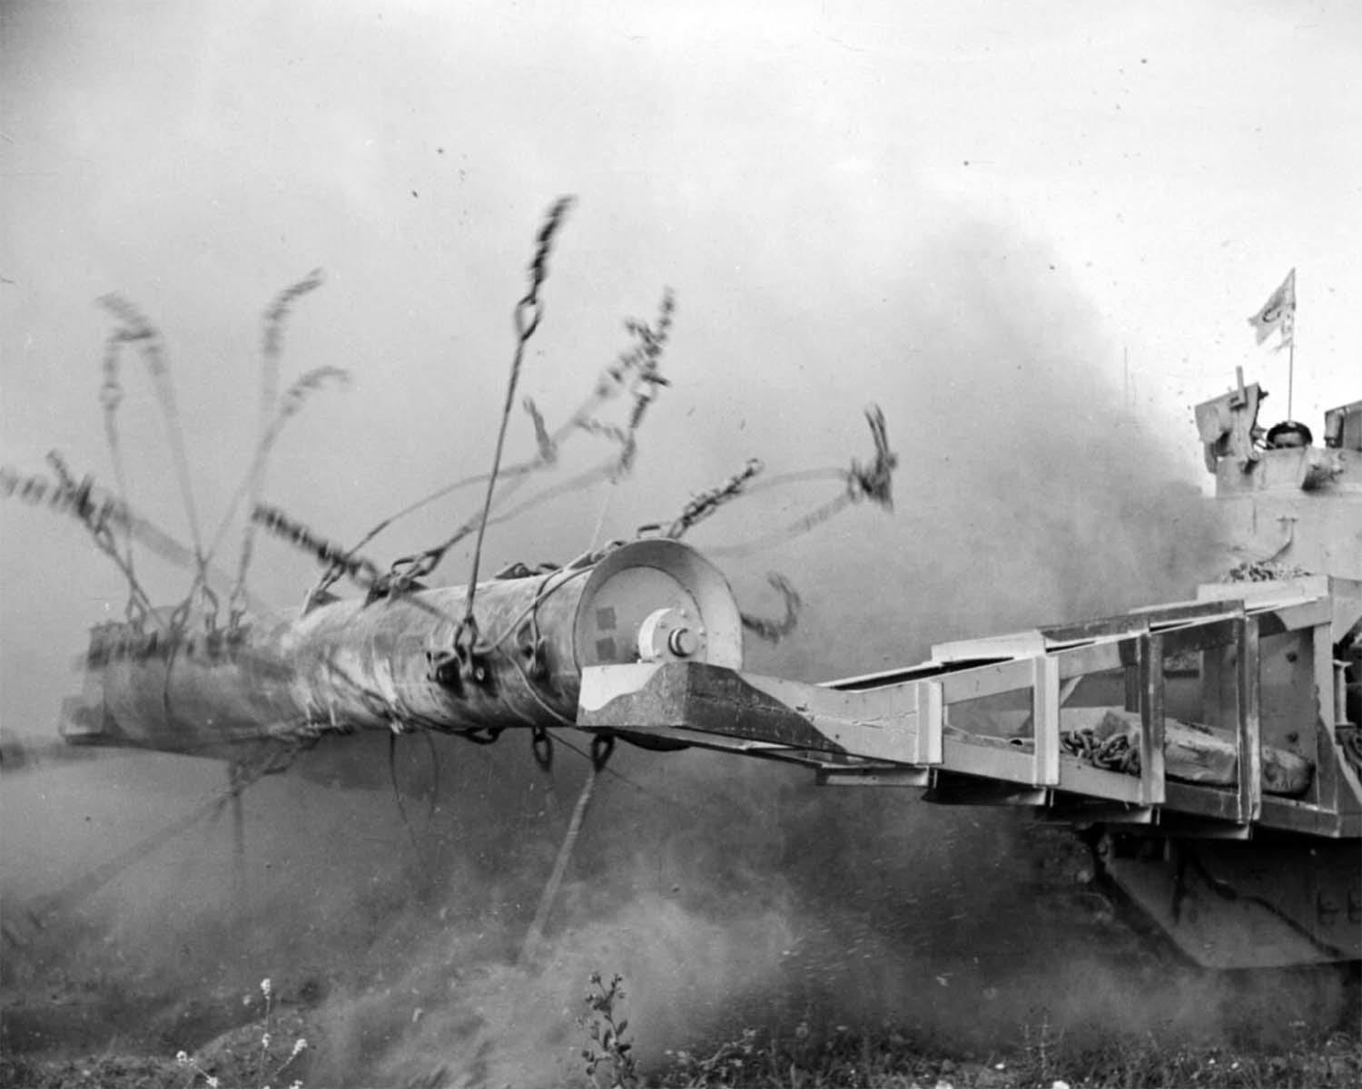
Close-up view of the revolving drum and chains at work on a Matilda Scorpion flail tank.
1
Jack Swaab: Field of Fire - Diary of a Gunner Officer

